AMERICAN SOCIETY OF PROFESSIONAL ESTIMATORS – OC CHAPTER 3
Presents

PERMANENT MODULAR CONSTRUCTION
Presented by Virtual Speakers, Ron Savona and Dora Perez from Global Modular Inc.

Date: Wednesday, January 19, 2022

Time: 5:00 PM – 6:00 PM PST

Location: Microsoft Teams meeting, Join on your computer or mobile app: Click here to join the meeting

Or call in (audio only): +1 925-412-3623, ID: 273 428 935#
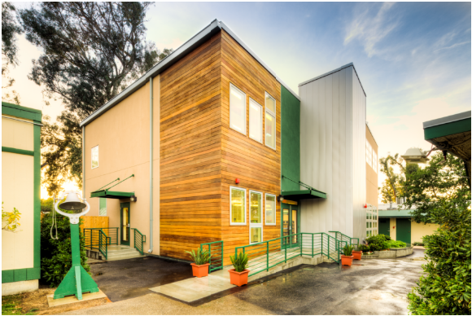
We are a General Contractor and Manufacturer of DSA and HCD approved Modular Buildings. Global Modular Inc. has been in the Modular Building Business for over 20 years and has assembled a team of the industry’s most talented and experienced individuals. From our management team to the craftsmen who design and build the structures; we have employed the brightest and the best.

Global Modular Inc. factory and refurbishment centers have the infrastructure and capability to design, manufacture new or refurbish pre-owned buildings in a fraction of the time it takes to site build the same building. Our buildings are designed to the same codes as site-built buildings.

Global Modular Inc. provides modular buildings for the education, commercial, healthcare and government markets. Our buildings are designed with longevity in mind; while our business practices model long-term relationships through superior customer service, surpassing all in this industry.


EDUCATION
ETHICS
STANDARDS
CERTIFICATION
FELLOWSHIP
PROFESSIONALISM

